Mfundo Mokhoantle
4549923
- Algorithm 1 consists of two nested loops, which equates the algorithm to O(n^2) worst-case run time. The outer loop runs at n times, scanning through the array for the positive integers. The inner loop also runs on n time for worst case, with its function being finding the negative version of the integer if available. This results in O(n) x O(n) = O(n^2), which is its worst case running time and the tightest bound simultaneously.

Algorithm 2 uses a two-pointer method when it comes to sorting the array, similar to algorithm 1. Pointer j starts at the last index while I starts as the first index, with one of them moving inward each iteration. In the case that a pair is found, both pointers move inward. Because the only move inwards, the can only move n times, therefore resulting in the worst-case running time being O(n).
- Algorithm 2 is a more efficient algorithm in accordance with asymptotic running time. Algorithm 2 grows linearly, while algorithm 2 grows exponentially, meaning that its speed grows at a higher rate then algorithm 1.
- ..
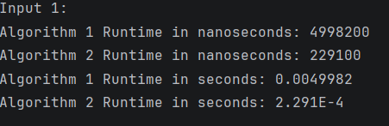

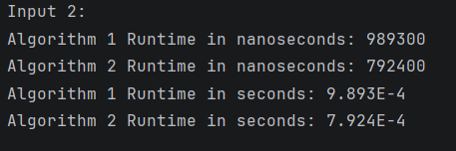

- Yes it does, with both input files given algorithm 2 runs the code and finishes faster then algorithm 1.
- .

n | Algorithm 1 | Algorithm
400 | 0.0000213 | 0.0000189
800 | 0.0000691 | 0.000035
1600 | 0.0002536 | 0.0001197
3200 | 0.0006482 | 0.0001438
6400 | 0.0018005 | 0.0003538
12800 | 0.005961 | 0.0004871
25600 | 0.0206383 | 0.0009222
51200 | 0.0723061 | 0.0013102

- .
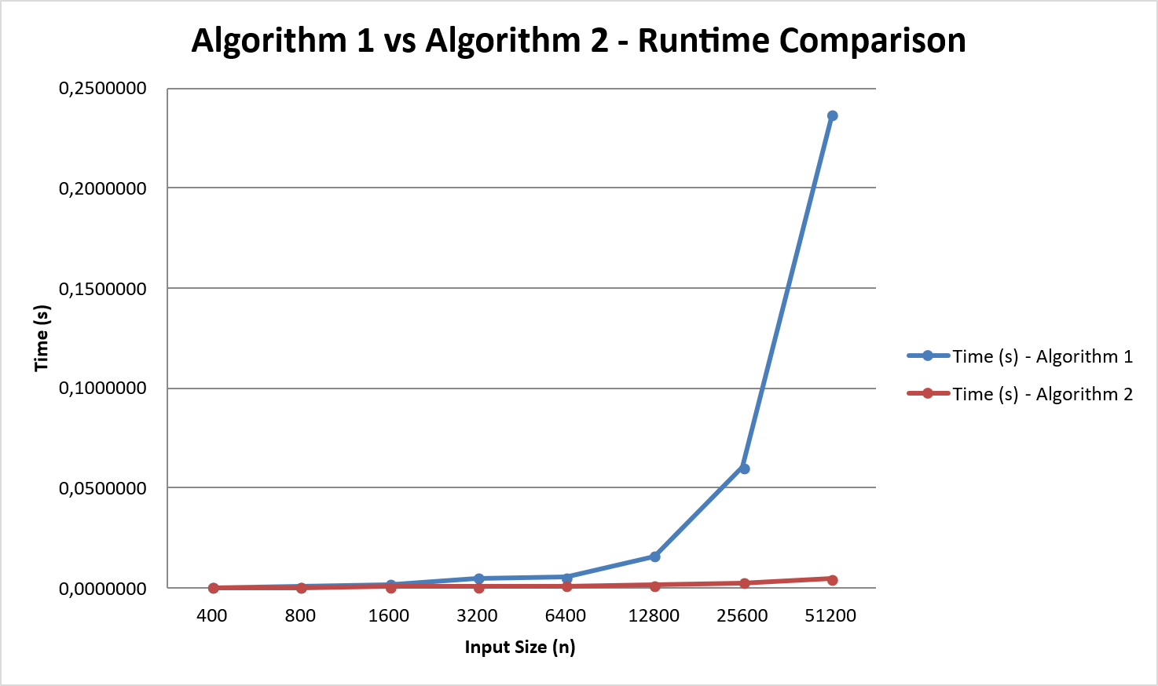
- It does correspond with my previous answer. Algorithm one shows exponential growth rate, with the algorithm’s time growing way faster compared to Algorithm 2’s linear growth rate.

